April 9, 2020

The Honorable William Barr
Attorney General
U.S. Department of Justice
950 Pennsylvania Avenue, NW
Washington, DC 20530-0001

Dear Attorney General Barr:

Our country is experiencing an unprecedented public health emergency with the Coronavirus (COVID-19) outbreak. Paramedics and emergency medical technicians (EMTs) employed by governmental and nongovernmental emergency medical service (EMS) agencies are on the front lines of testing, treating and transporting Americans with the virus. In their time of self-sacrifice, we request that you ensure that all paramedics and EMTs including those employed by private for-profit EMS agencies are covered by the Public Safety Officers’ Benefit (PSOB) program during this declared national emergency.

Approximately one-third of communities around the U.S. have chosen to have their emergency medical care and transport services provided by private for-profit EMS agencies including New Rochelle, New York, which became an early epicenter for COVID-19 in the U.S. PSOB coverage, however, currently only applies to those police officers, firefighters, paramedics and EMTs employed by a federal, state, local government or non-profit entity. Then-Attorney General John Ashcroft at the request of the American Ambulance Association, made an exception after September 11, and covered the paramedics and EMTs employed by private for-profit EMS agencies who died while providing aid when the World Trade Center collapsed on them.

Paramedics and EMTs employed by private for-profit EMS agencies provide the same public service as their fellow first responders. Due to the sometimes dangerous environments in which they work, insurance companies will not provide line of duty death policies for paramedics and EMTs. If a policy is available, the premiums are cost-prohibitive and the coverage level is significantly less than the level of benefit under the PSOB program. It is unfair to penalize these first responders and their families simply because their employer is a private for-profit agency.

On behalf of the tens of thousands of private sector paramedics and EMTs and the agencies that employ them, we respectfully request that you extend PSOB program coverage during this national health emergency to paramedics and EMTs employed by private for-profit EMS agencies.

Please do not hesitate to have a member of your staff reach out to Tristan North at (202) 902-9025 or Kim Krenik at (202) 365-8342 if you have any questions regarding this request.

Thank you for your consideration and we look forward to your response.

Sincerely, Sincerely,

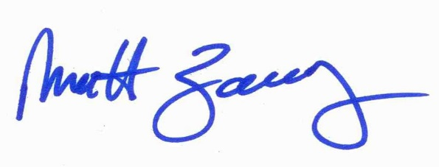
Aarron Reinert Matt Zavadsky, MS-HSA, NREMT
President President
American Ambulance Association National Association of Emergency Medical Technicians

About the American Ambulance Association

The AAA is the primary association for ground ambulance service suppliers/providers, including governmental entities, volunteer services, private for-profit, private not-for-profit, and hospital-based ambulance services. Our members provide emergency and non-emergency medical transportation services to more than 75 percent of the U.S. population. AAA members serve patients in all 50 states and provide services in urban, rural, and super-rural areas. As the National Highway Transportation Safety Administration identified in its 2013 report on emergency services, EMS-only systems – such as our members – provide the vast majority of emergency ambulance services throughout America.

About the National Association of Emergency Medical Technicians

NAEMT is the nation’s only organization that represents and serves the professional interests of all EMS practitioners, including paramedics, emergency medical technicians, emergency medical responders, and other professionals providing prehospital and out-of-hospital emergent, urgent or preventive medical care. NAEMT’s 72,000 members work in all sectors of EMS, including government service agencies, fire departments, hospital-based ambulance services, private companies, industrial and special operations settings, and in the military.

